System overview (from thesis)
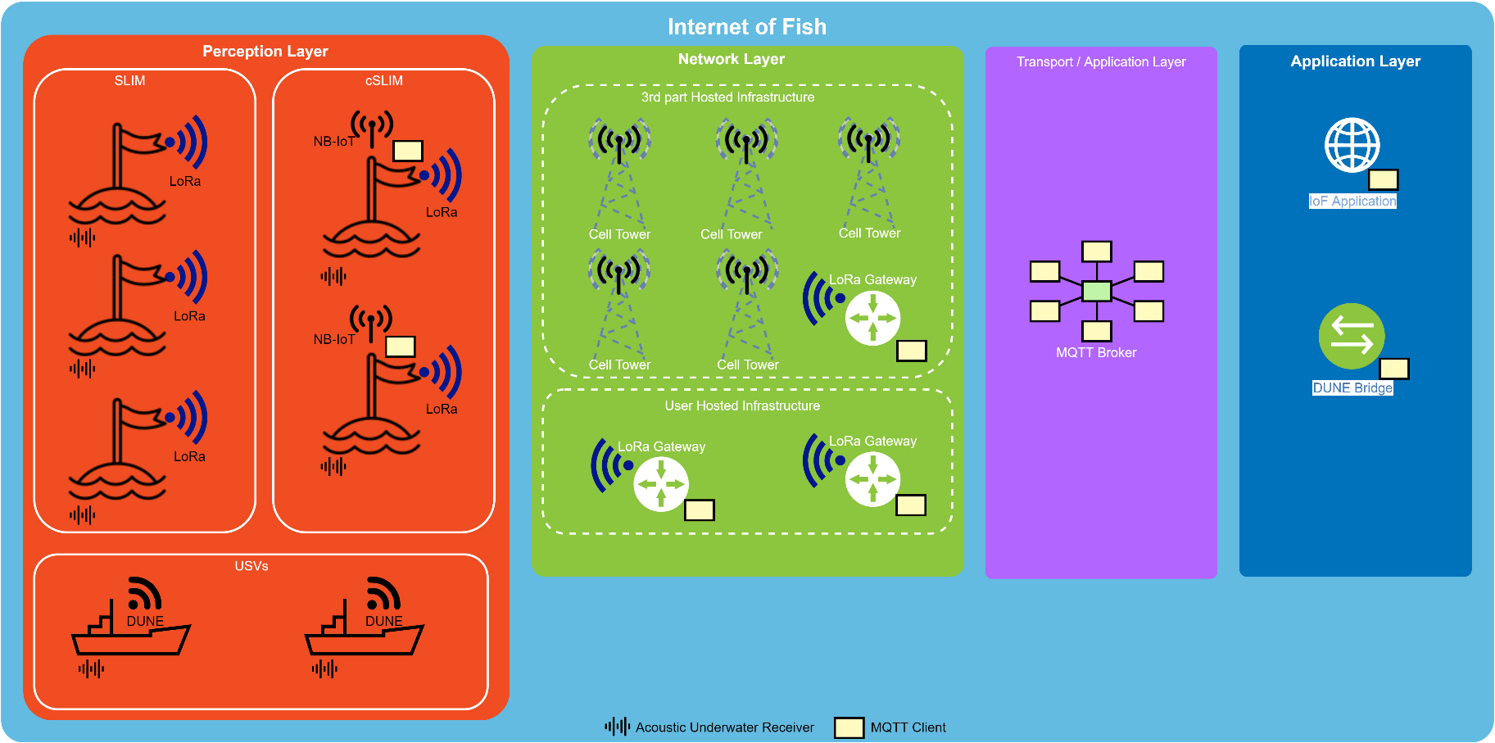

The main system components consist of the acoustic telemetry receiver detecting the acoustic tag transmissions, the cSLIM buoy controller synchronizing the acoustic receivers, and forwarding the data through the LoRa gateway or NB-IoT network to an MQTT broker. The MQTT broker forwards the published message to subscribed applications as the IoF application and DUNE bridge.

4.1 Acoustic tags and telemetry receivers
The acoustic Telemetry receiver is a TBR 700 RT from Thelma BioTel.
Uses RS-485 interface to communicate with the buoy controller. It uses differential pair of signals and can send or receive one character every 10ms. The acoustic sensor uses internal clock and time to timestamp tag detections. The time can be set using a predefined message format, synchronizing the last received character. Also a shorter message without time data can be received every 10s to correct internal clock drift. SEE TBS Live datasheet for more info.

4.2 cSLIM buoy controller and sea buoy
This device is the hart of the sea buoy. It synchronizes the time of the TBR acoustic receiver, receives tag-detections and forwards them to mainland using LPWAN technology. The module ALSO transmits its position, status and time drift at regular intervals.

4.3 LoRa Gateway and MQTT broker
The LoRa gateway used is the MultiTech Conduit (indoor and outdoor versions exist).The gateway can be connected to Ethernet and to the cellular network, supporting 2G, 3G and ¤g LTE.
Running Node-RED; The gateway forwards LoRaWAN payload to the MQTT broker. For cSLIM application, only the LoRaWAN payload is forwarded to make the messages equal to those transmitted using NB-IoT/MQTT. Have been edited, packing data in JSON objects together with LoRaWAN parameters.
The MQTT broker, running on a virtual machine, is a mosquitto broker with its access restricted by username and password.

4.4 IoF application
The IoF application is connected to the MQTT broker, and subscribed to the buoy controller publish topic. The newest back-end version receives IoF messages packed in JSON containing relevant LoRa parameters and saved received information in a database. The Database is accessed by the fron-end, displaying information to the user. As the NEWEST IoF application expects additional LoRa information, it is currently incompatible with the LoRa Gateways used in the cSLIM or communication using BN-IoT. However, for applications using LoRa Gateways running the SLIM Node-RED flow by Rundhovde, cSLIM should be supported.

4.5 DUNE bridge
DUNE bridge, running in a DUNE environment, is subscribed to the MQTT broker and cSLIM publish topic. Upon receiving messages, the application converts the TBR status and tag detections to appropriate IMC messages. Information about the positions of the acoustic sensor is gathered using buoy controller status emssages.

